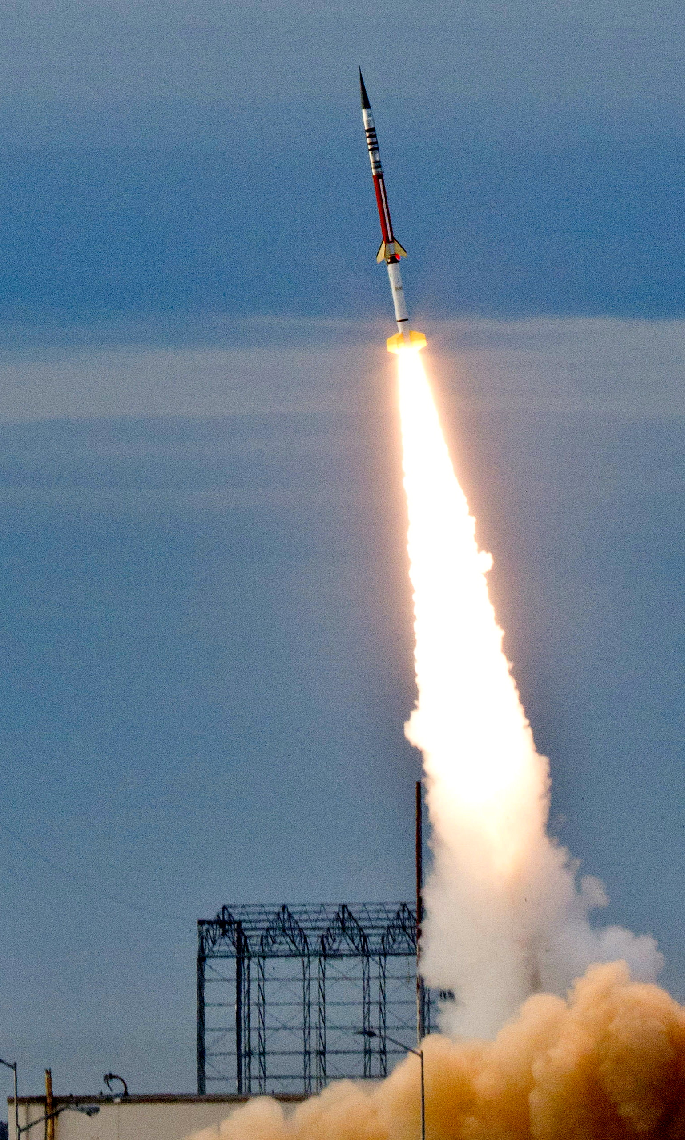
Can Go Fast
By Clark Ness

Visit www.clarkness.com and www.readinghawk.com
for more free ebooks and stories.

Reading Level: Lexile® Measure 170L
Flesch-Kincaid Grade Level 0.2

Nonfiction
Photograph: NASA/Wallops
A rocket can go fast.
1
Photograph: NASA/Wallops
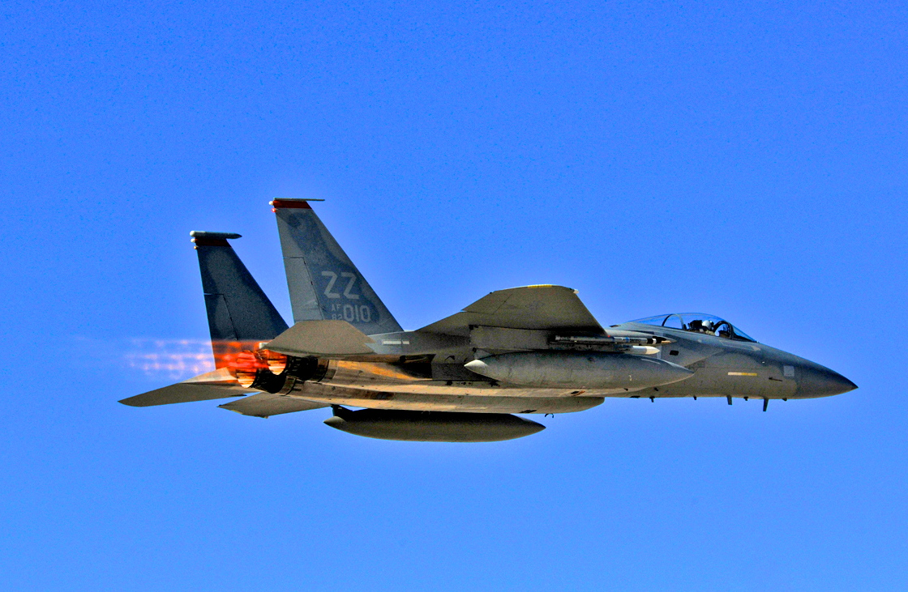
A jet can go fast.
2
U.S. Air Force photo/Chief Master Sgt. Gary Emery
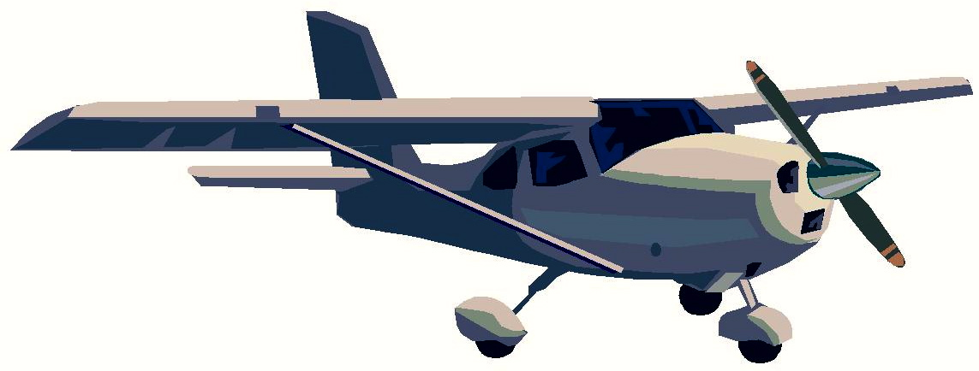
An airplane can go fast.
3
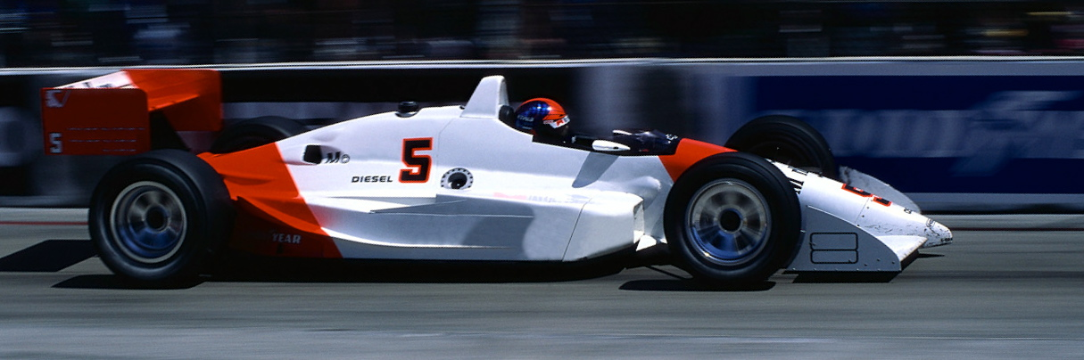
A race car can go fast.
4
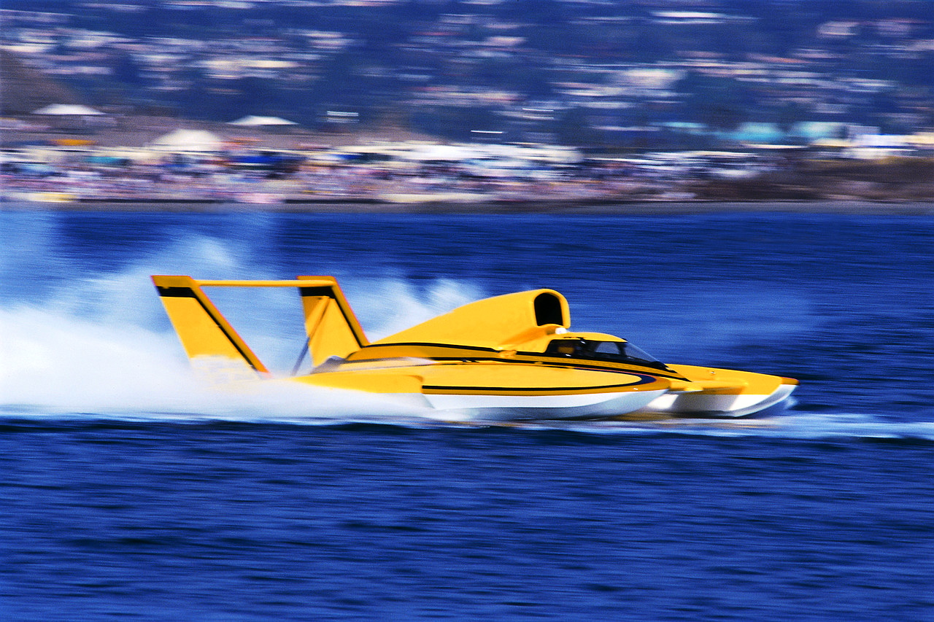
A boat can go fast.
5
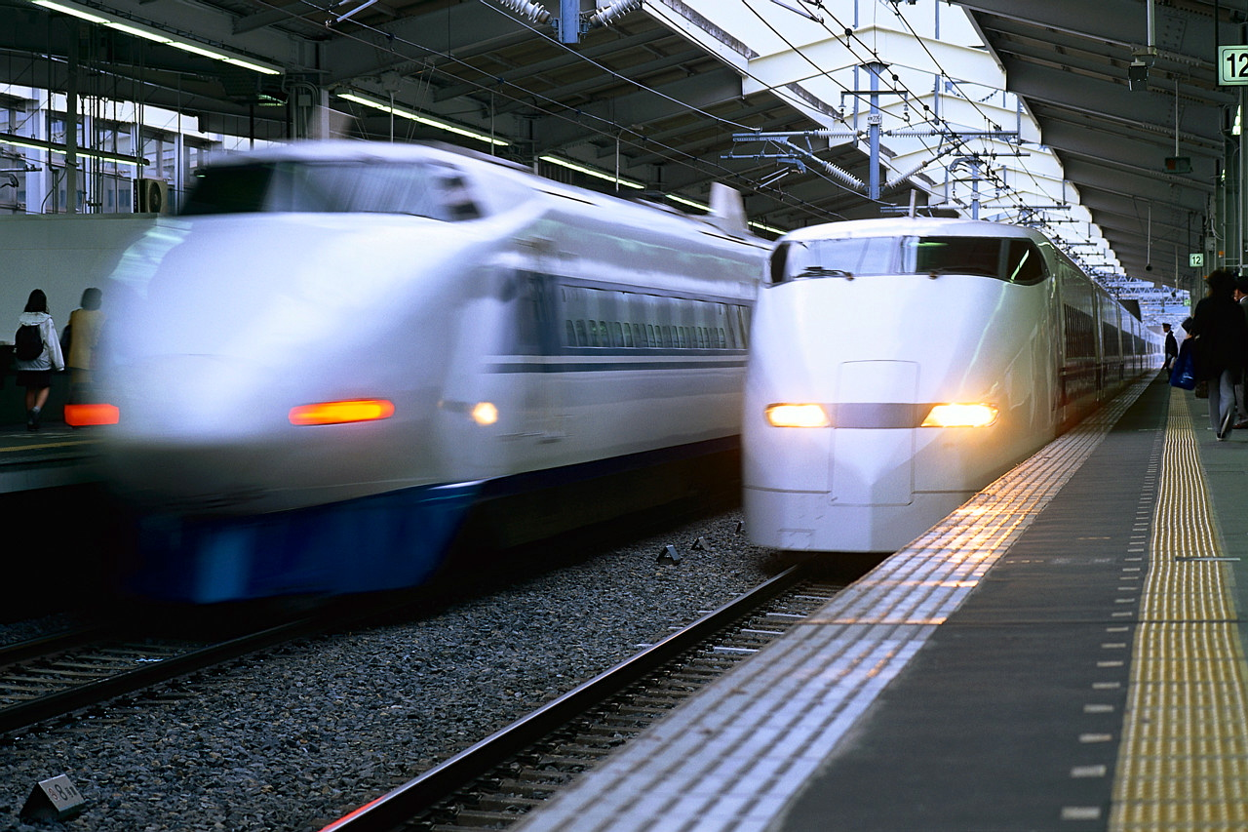
A train can go fast.
6
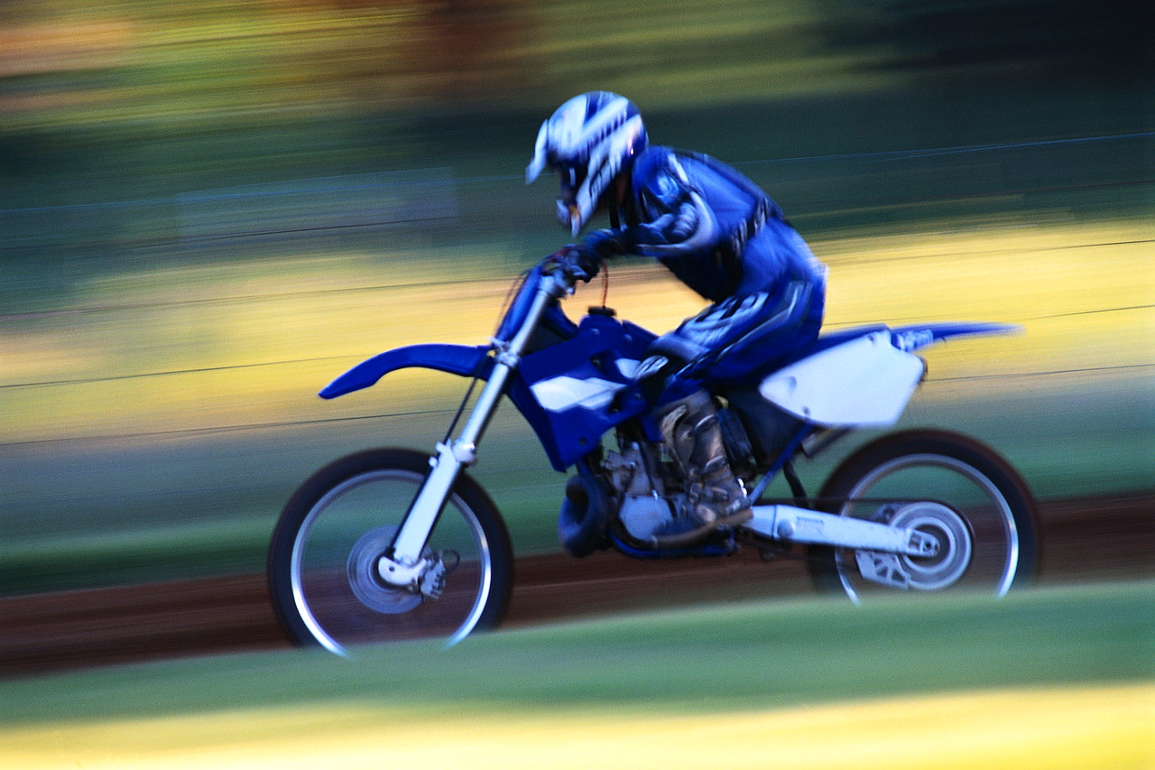
A motorcycle can go fast.
7
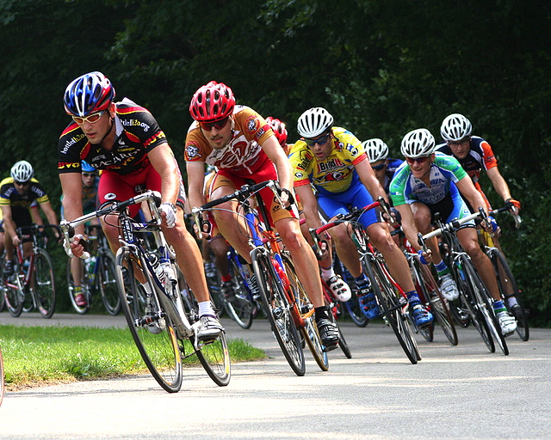
A bicycle can go fast.
More free ebooks and stories are available at www.clarkness.com and www.readinghawk.com.
Text Copyright © 2013 by Clark Ness. Images are from Microsoft Office Images unless otherwise noted.
Permission is granted for printing, photocopying, emailing, recording, storing in a retrieval system, and transmitting this story in any form, or by any means, mechanical and/or electronic. Sale of this story and/or uploading to a commercial bookstore or commercial website is strictly forbidden without prior written permission.
8
Photograph © Rob Annis - flickr.com

